# User Manual

# Encrypting a File

1. Click File, then open encrypt.

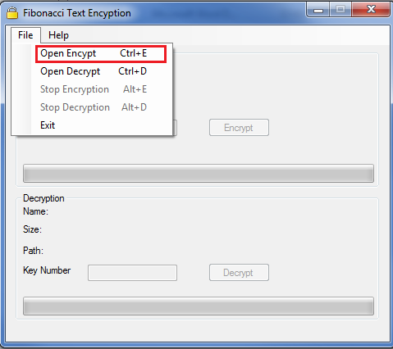

1. Then Select the desired text file for encryption

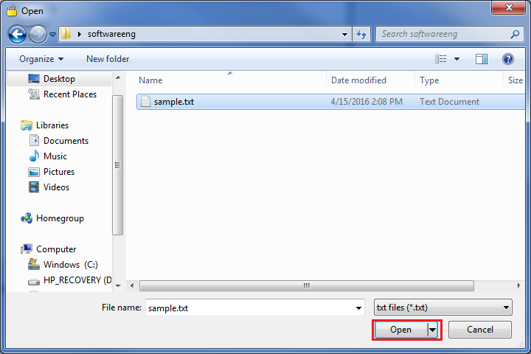

1. This option will load the text document for encryption.
2. Enter a unique key number.

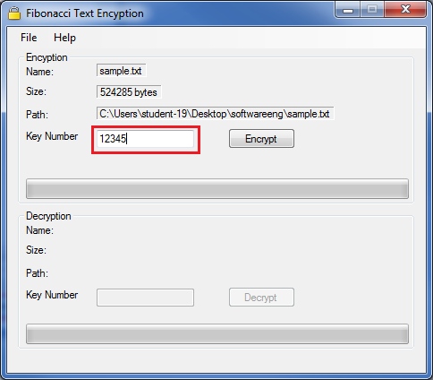

1. To encrypt the file, click the encryption button

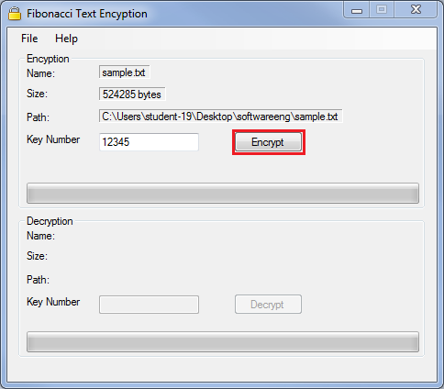

1. At any time you may stop the encryption by clicking the Stop Encryption button in File Menu, when encrypting a file this option will be available for clicking.

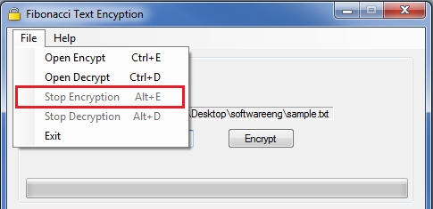

# Decrypting a file

1. Click File, then Open Decrypt.

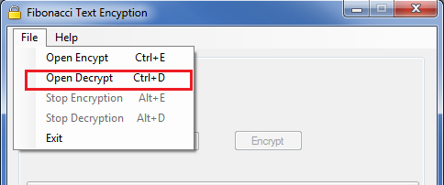

1. Then Select the desired .locked file for decryption

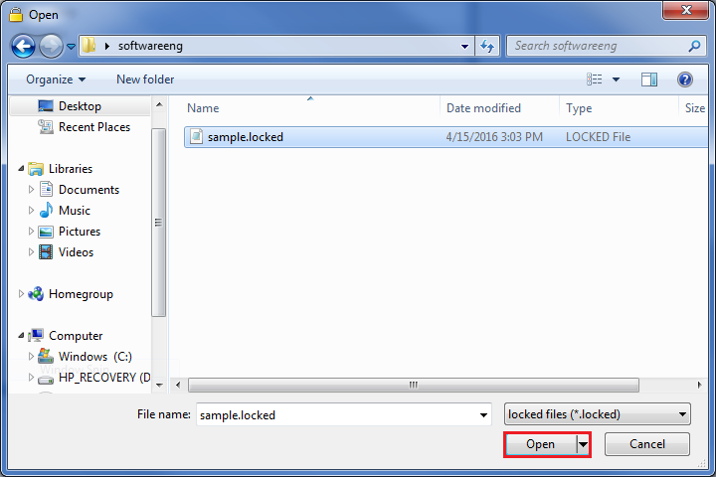

1. This option will load the .locked document for decryption.
2. Enter a unique key number.

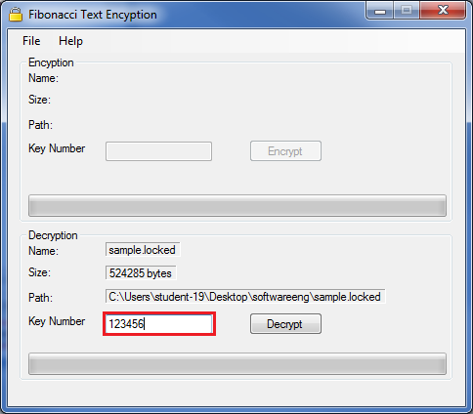

1. To decrypt the file, click the Decryption button

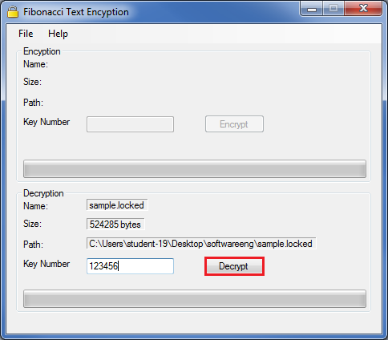

1. At any time you may stop the decryption by clicking the Stop Decryption button in File Menu, when decrypting a file this option will be available for clicking.

